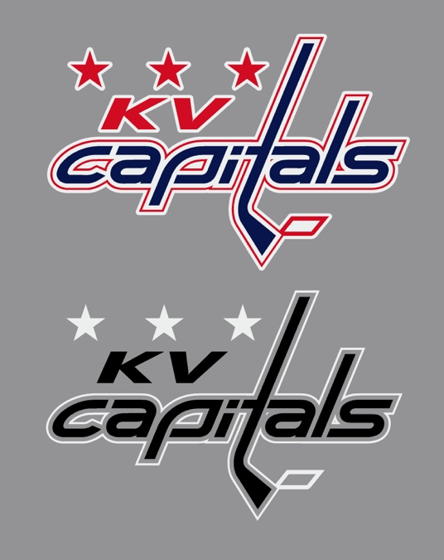

KV Capitals U15
Coach:
Manager:

Dear local business,

TEAM NAME is looking for help from the community as we start our 2022/2023 hockey season in the Kennebecasis Valley.

“Small blurb about your team and why you are requesting sponsorship.”

As one way to help our kids, the Capitals are proposing: Your sponsorship idea here. Remember, any jersey sponsorship is only one year and cannot conflict with any current sponsorship that is already on the jersey. It is best that you consult the KVMHA board before you agree with a sponsor to be sure you are not in conflict. Any new patches or logos must be removed before being returned to KVMHA. If damage is caused to the jersey set. You and your team will be responsible for replacing them at a cost of around $1800 per set.

Our team will play XX scheduled league games within Southern New Brunswick (Sussex to St. Stephen). This would expose your business to potentially XXXX people per season. Our team will also attend X tournaments within the Atlantic region to further the reach of your investment.

TEAM NAME is grateful for your consideration of our proposal. If you have a different idea of how you can help our kids, please feel free to reach out. We are open to finding an opportunity that works for everyone.

Thank you for your time,

Manager
KV Capitals

