Operational Plan for Quispamsis Memorial Arena
Responsibility – Arenas and Pool – Community Services Department Phase 1
- INTRODUCTION
  - The Town of Quispamsis will continue to follow the Provincial State of Emergency, the Provincial Recovery Plan, and the guidance and direction of the Office of the Chief Medical Officer of Health (CMOH) as its recreation facilities are re-opened during the COVID-19 pandemic.
  - The following document outlines the various roles and responsibilities of ice user groups at QMA.
  - The current phase of this plan (Phase 1) will allow more activities to return to the QMA. Nonmedical faces masks must be worn upon entering the facility, until the time that the skaters take to the ice.
  - A screening process is required for the arena given the likelihood that more than 50 persons will be in the facility at the same time. Screening and contact tracing are the responsibility of the user.
  - Physical distancing measures of 2 metres will be required unless exempted as per CMOH guidelines. Traffic flow and disinfecting measures will be implemented. The Town of Quispamsis will limit access to areas of the facility due to inability to ensure physical distancing, as per the Provincial Order, in the face of added requirements in response to COVID-19.
  - Future phases of this Operational Plan will also follow the Provincial State of Emergency, the Provincial Recovery Plan, and the guidance and direction of CMOH as changes happen.

- ON-ICE MEASURES
  - Each user group shall be represented by an organization or oversight agency with an Operational Plan that the group is required to follow. These plans shall follow the guidance of the CMOH. Operational Plans shall be provided to the Town of Quispamsis prior to on-ice activities and must align with the Town of Quispamsis’s Operational Plan and applicable governing provincial or national sport bodies.
  - The current Provincial Mandatory Order allows sports to be played when done in compliance with CMOH guidelines. It is recognized that when sports are played 2 metres may not always be maintained between participants. As per the requirements of the CMOH, a risk mitigation plan must be developed by the group booking ice.

- OFF-ICE MEASURES
  - Lobby area, players entrance and general traffic flow
The QMA main lobby is the main entrance point. Players will be directed to assigned dressing rooms. Once permitted access, parents, guardians, spectators will be directed to assigned seating locations in the bleachers. Sections of the bleachers will be clearly marked with numbers that must correspond with the team’s dressing room.
Markings, timing of entrance and/or signage within the facility has been installed to further limit cross flow of traffic.
Exiting the facility is through the singular door past the dressing room corridor.
  - Signage
In addition to controlling traffic flow, signage will be posted throughout the facility to emphasize the importance of frequent handwashing and proper hygiene practices.

  - Spacing between user groups
Users are to arrive no more than 30 minutes before scheduled ice time and leave as soon as possible following the end of the game, no later than 30 minutes. No gathering in the parking lot.
  - Food and beverages
Food and beverage services will not be available during this phase through the canteen service provider.
Water bottles should be filled prior to coming to the facility. There is to be no sharing of water containers.
  - Dressing rooms
Dressing rooms will be available as well as washrooms within the dressing rooms, however they are to be used at your own risk. Showers within the dressing rooms will not be available at this time.
  - Participants who can arrive dressed will be directed to an area of the stands to complete preparations for their on-ice activity.
  - Warm-up areas
If a group wishes to warm up off ice, they must keep in mind the 30-minute arrival time, and they must warm up outside of the facility or within the allocated dressing room space. No gathering in the parking lot, hallways or common areas.
  - Spectators/Guardians – Practices and/or Games
Spectators/Guardians must enter through the main front entrance.
Spectators/guardians will be limited to one per player and must maintain physical distancing of 2 metres while in the arena.
Spectators can only access the facility 15 minutes prior to game time entering through the main entrance, register, providing name and phone number for contact tracing as per the Provincial requirements to the HOME team liaison, then travel to the designated seating area in the bleachers which is to be reflective of the assigned dressing rooms.
Spectators are not permitted to view the activity from any other area within the facility and must remain seated at all times.
Non-medical masks must be worn while in the facility at all times.
Once the ice time is over, spectators/guardians will exit the arena past the dressing rooms through the single end door.
  - Spitting
There is no spitting permitted in the facility.
  - Facility sanitizing
Every attempt will be made to clean and disinfect commonly touched surfaces such as interior and exterior door handles and railings by Town staff.
Washrooms will be cleaned and sanitized on a regular basis throughout the day by Town staff.
Every attempt will be made to sanitize benches, ice rink gate handles, penalty boxes and the score keeper’s booth by Town staff between each user group, unless these areas are not used.
All other sanitizing is the responsibility of the licensee or user group, ie. washroom if utilized. It is strongly recommended that users bring individual hand sanitizer for personal use.

Employees will perform the following between users: spray sanitize players benches and timekeeper area, if utilized, scrape/flood the ice surface, then they will sanitize bleacher area and dressing rooms for the next group of users. When time allows, staff will sanitize/clean general washroom and lobby areas. Users must be respectful that by times this maintenance will require longer than a normal 15-minute flood time.
All users please remain in the dressing rooms until such time as the buzzer is sounded.
  - Hand-washing facilities
Hand washing is available in the main public washrooms.
  - Employee Interactions
Physical distancing of 2 metres between employees and the public is mandatory. Face masks will be worn by the employees at all times.
  - Employee Screening
The Town of Quispamsis has implemented a self-screening process following specific screening questions prior to the start of shift, including a temperature check (digital thermometer will be provided to staff).
  - Patron Screening
Patrons entering the facility are required to document, the date, time, and their contact information through a screening process. It will be the responsibility of the group renting the facility to manage this information and supply to Public Health when requested. Any patron/participant showing symptoms shall not enter the facility and should immediately return home and call 811.

- ILLNESSES OR SYMPTOMS OF STAFF AND PATRONS/PARTICIPANTS
  - Patron / Participant - Should a patron / participant develop symptoms during their time in the facility, they must leave the facility immediately and contact 811 and follow their direction.
  - Should they be tested and found positive for COVID-19, we will follow the communication protocols from 811 as recommended by the CMOH.
  - Staff – If a Staff member develops symptoms of COVID-19, they will leave the facility and immediately contact their Supervisor, Manager or Director. The affected employee will be required to contact 811 as recommended by the CMOH. Additional measures provided by the Town’s Human Resources Department will be followed.
Regional Public Health will be involved to manage any instances or outbreak and ensure contacts are identified, public health measures are in place and will lead any communication that is required.

- Closure of the Arena
A closure may be directed if there is a COVID-19 outbreak, a change in the Provincial Mandatory Order, or in any other case as directed by the CMOH. The facility will close and cannot reopen until authorized by the CMOH.
User groups may lose access to the arena if they do not follow this Operational Plan in addition to their own.

- Acknowledgement of Town’s Operational Plan
  - User groups will be provided a copy of the QMA COVID-19 Operational Plan and must sign that they have read and agreed to the plan. It is the responsibility of the individual renting the ice to disseminate the information to all their users and ensure that they clearly understand the protocols in place and know what to expect before arriving at the facility.
  - All groups and or organizations must also provide to the Town of Quispamsis an operational plan for review and approval.
  - Both operational plans (Town of Quispamsis and Organization/Groups) must be adhered to by the users.
  - Individual ice rental users must abide by the QMA operational plan.
- Attachment:
  - Town of Quispamsis Traffic Flow Plan.

Signature _______________________________________ Date ______________________________

Signage has been adjusted to 2m – will adjust on Op Plan.

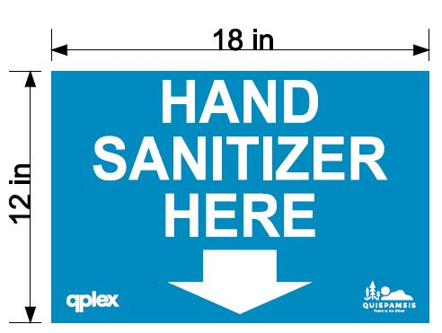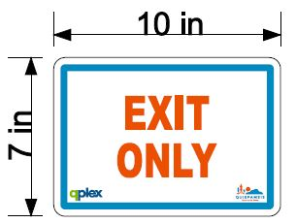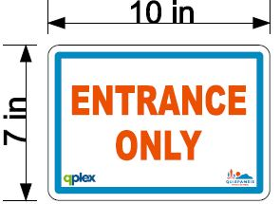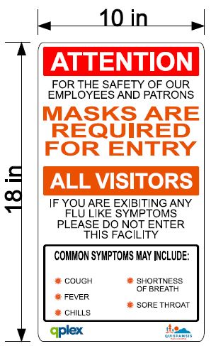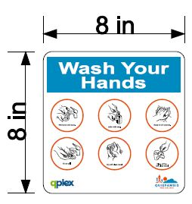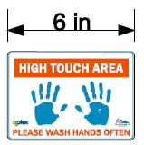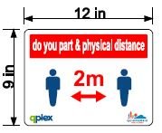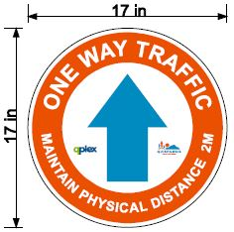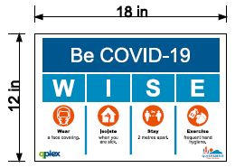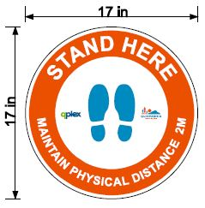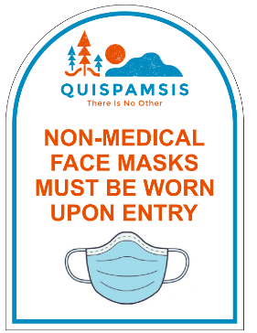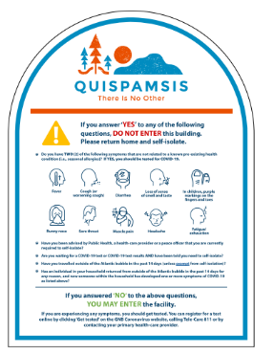

All areas equipped with appropriate signage above.
For dates of sign installation please see sign location checklist I:\12 Rec Sport Cultural 3200-3399\Recreational and Sport Facilities Operations 3270\General info\COVID - 19\Facilities documents\Sign Locations

